EE 202 Lab Report 5

Seth Schachter

Javier Macossay-Hernández

**Problem 1**

Vs 1 0 ac 3

R 1 2 1k

C 2 0 1u

L 2 0 1m

.ac lin 100 1k 1MEG

.probe V(L)

.end

Magnitude –

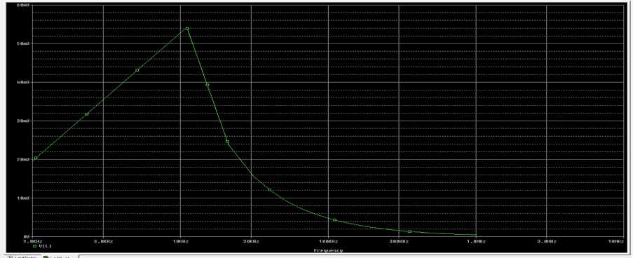

Phase –

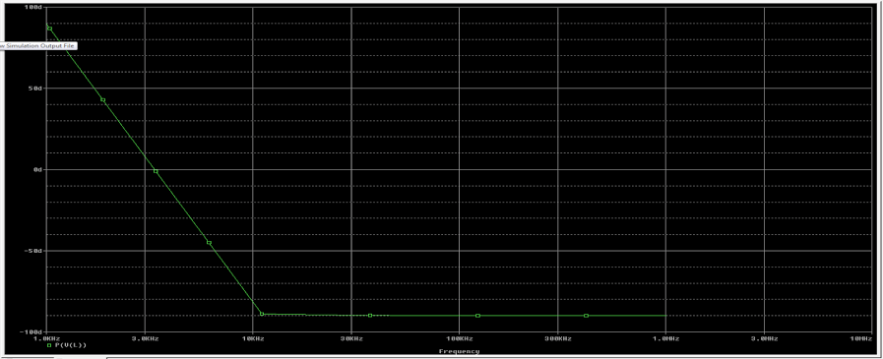

**Problem 2**

Vs1 0 1 ac 2

R1 1 2 1K

L 2 3 1m

Vs2 3 0 dc 5

C 2 4 1u

R2 4 0 10K

.ac dec 100 1K 1MEG

.probe V(R2)

.end

Magnitude –

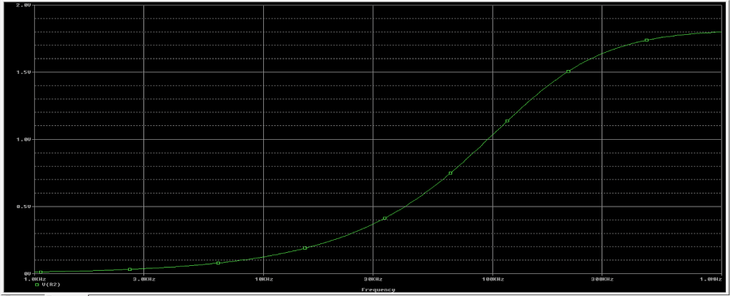

Phase –

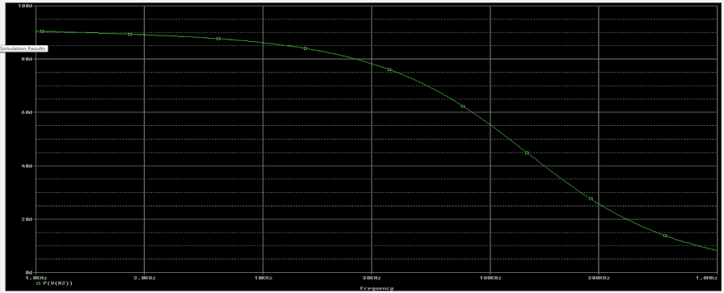

**Problem 3**

Vs 0 1 sin(0,2,1k)

C 1 2 10u ic=5

L 2 0 10m ic=0

R 2 0 1k

.tran 0 100m uic

.probe I(R)

.end

